Yearly Membership Pin

6 Years

5 Years

4 Years

3 Years

2 Year

1 Year

Attendance Awards
(75% of all meetings and 50% of all outings)

Camping Awards
1st Place – Nights
2nd Place – Nights
3rd Place – Nights

Special Presentations

Slide Show

Camping Award provided by the
generous donation by

THANK YOU!

Boy Scouts of America
Troop 130
Sequoia Area Council

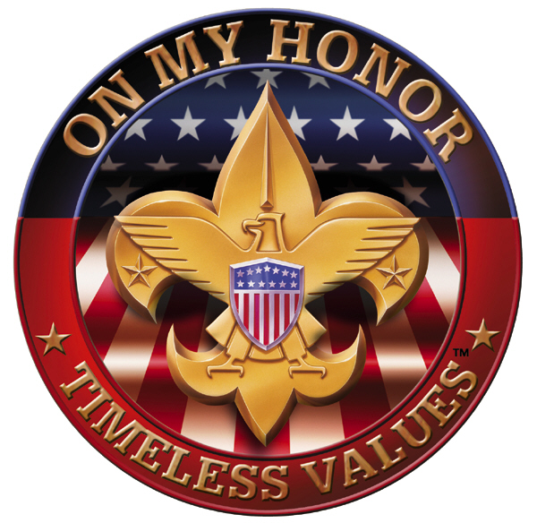

Court of Honor

[Replace with Date]

Charter Organization
Good Shepard Lutheran Church
Fresno, CA

Troop 130 Fall Court of Honor

Opening Ceremony
Flag Ceremony

Welcome
Master of Ceremonies
[Replace with M/C]

Friends of Scouting
[Replace] – Scout Executive

Rank Advancement
Ken Bryson – Scoutmaster

Merit Badge Presentations
Ken Bryson – Scoutmaster

Special Awards
Ken Bryson – Scoutmaster
Yearly Membership Awards
Attendance Awards
Camping Awards
Dick Albert Award
Special Presentation

Closing
Retiring of the Colors
Scout Vespers
Closing Remarks
Refreshments

Rank Advancement

Scout

Tenderfoot

Second Class

First Class

Star

Life

Eagle

Merit Badges

