Merit Badges (cont)

Merit Badges (cont)

Special Awards

Special Presentation
Slide Show
Troop Historian

Boy Scouts of America
Troop 130
Sequoia Area Council

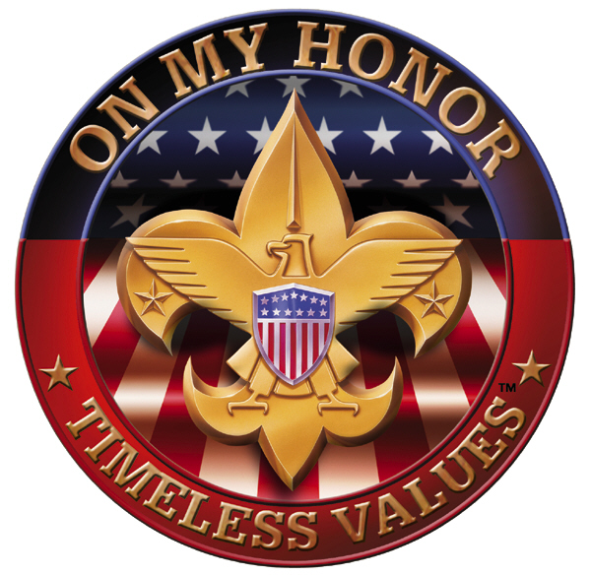

Court of Honor
--

Charter Organization
Good Shepard Lutheran Church
Fresno, CA

Troop 130 - Fall Court of Honor

Opening Ceremony
Flag Ceremony

Welcome
Master of Ceremonies

Rank Advancement
Ken Bryson – Scoutmaster

Merit Badge Presentations
Ken Bryson – Scoutmaster

Special Awards
Ken Bryson – Scoutmaster
Chawanakee Patches:
Asst. Scoutmaster

Closing
Retiring of the Colors
Scout Vespers
Closing Remarks
Refreshments

Rank Advancement

Scout

Tenderfoot

Second Class

First Class

Star

Life

Eagle

Merit Badges

